Team Gemini

Final Project Submission

Brandon Antosh

Adrian Imbert

Salman Siddiqui

Alex Santini

F-104 Starfighter

Dr. Richard Prazenica: AE432 – Section 02

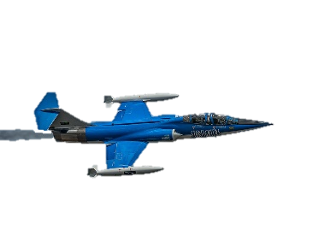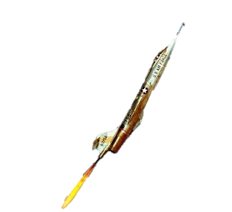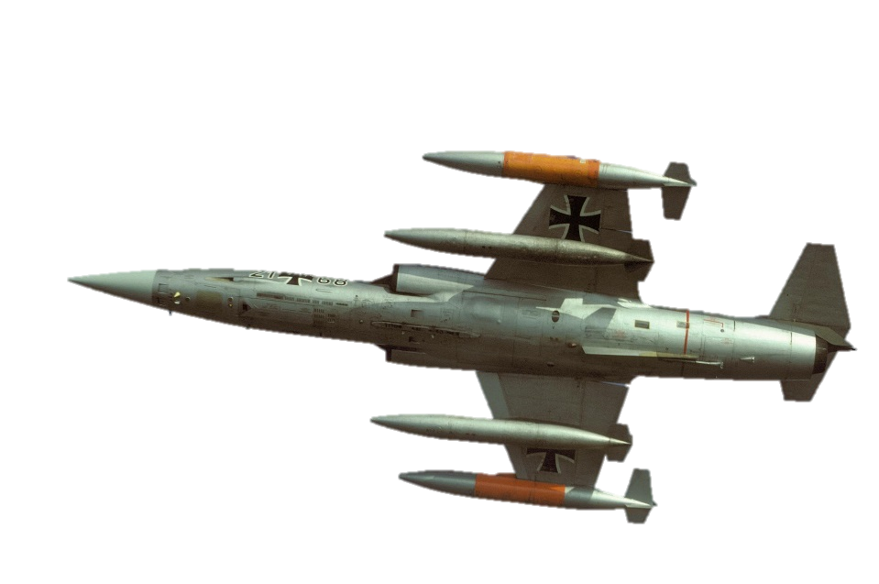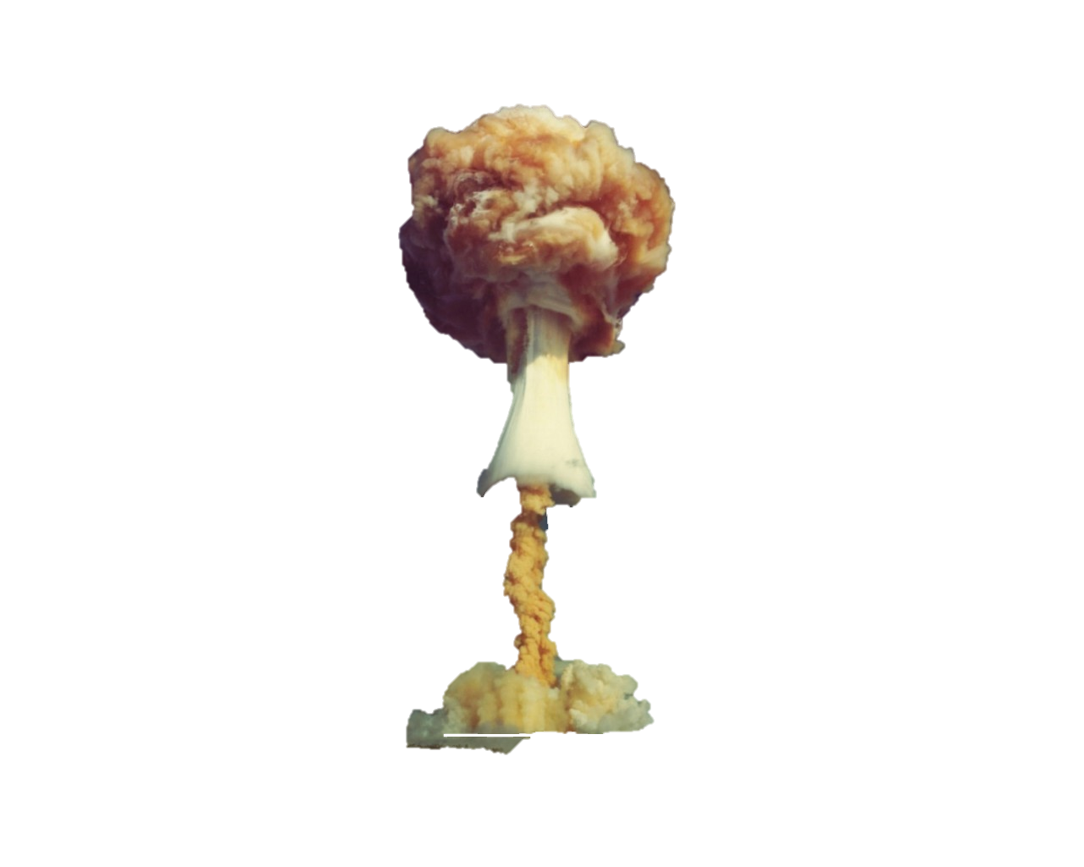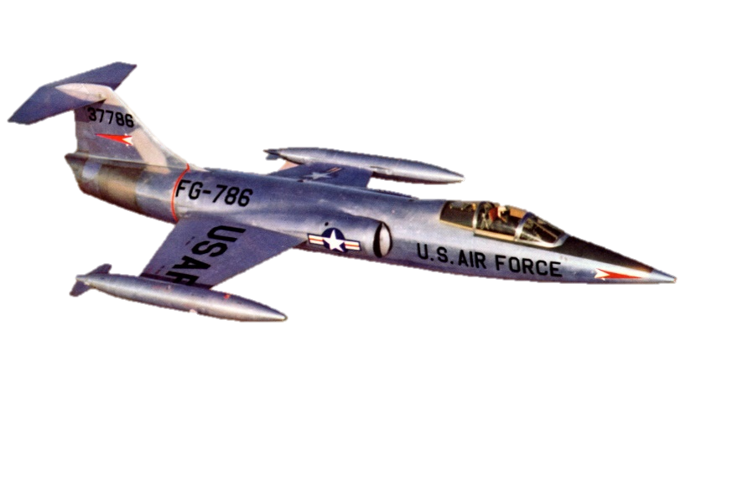

# 1. Simulation Development and Open-Loop Analysis

## 1.1 Aircraft Description & Capabilities

Developed by Lockheed for the United Stated Air Force, the F-104 Starfighter is a supersonic interceptor aircraft. The aircraft served in various operations for multiple nations from its introduction in 1958 to its retirement in 2004. The aircraft featured a radical wing design for the time. The F-104 had trapezoidal wings that were small, straight, and mid mounted because Lockheed had determined the shape provides the best efficiency during supersonic flight. The fuselage featured a high finesse ratio, meaning it is slender and tapered towards the aircraft’s sharp nose. This wing-fuselage combination gave the aircraft low drag except at high angles of attack where the induced drag becomes very high. The aircraft’s propulsion system was a single General Electric J79 turbojet engine. Because of the low drag, the thrust-to-drag ratio was excellent allowing maximum speeds to exceed Mach 2.



**Figure 1.1-** Lockheed F-104 Starfighter

The F-104 was known for having good acceleration, rate of climb, and of course, top speed. It was designed to operate at an optimal Mach number of 1.4. The aircraft also featured a very high thrust-to-weight ratio. As a result, this made the aircraft ideal for high-speed attacks, and its stability at high speeds made it formidable as a tactical nuke strike fighter. However, its sustained turn performance and lack of forgiveness to pilot error were issues. The aircraft would typically falter if it got into dog fights involving low-speed subsonic turns. At high angles of attack the aircraft would experience extreme pitch-up behavior and would eventually enter into an unrecoverable spin if extremely high angles were reached. Another issue was that the single engine configuration of the F-104 lacked the safety margins in case of engine failure, unlike two engine fighters.

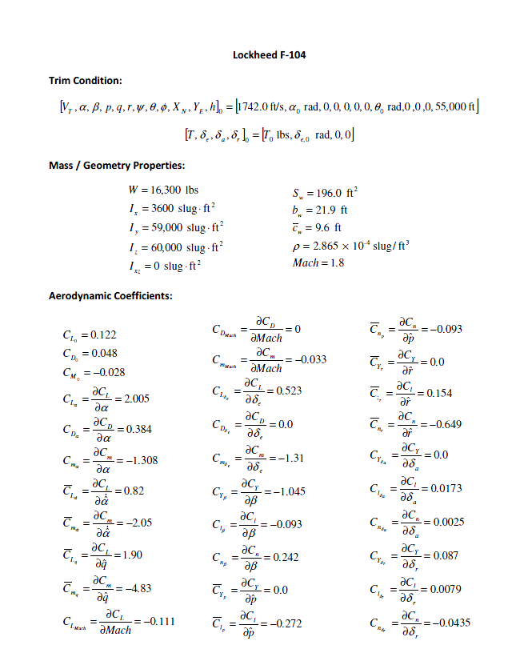

**Figure 1.2 -** Trim conditions and coefficients for the F-104 Starfighter

## 1.2 Simulation Development

The Simulink model created for the F-104 Starfighter is based off a complete model for Navion. Unlike the Navion, he F-104 is meant to operate at supersonic conditions and therefore modifications needed to be made to the original Simulink file. In order to do this, the coefficients shown in Figure 1-2 were inputted into the model and the MATLAB code was modified to be valid for the F-104 Starfighter.

## 1.3 Trim Conditions and Values

Prior to simulating the model for the F-104 Starfighter, the trim conditions were determined. As a result of being given the total velocity (VT), the trim angle of attack (αT), trim elevator deflection (δe) and trim thrust (T­T) were found through the use of our Matlab code from HW #3. Other necessary values were found through the use of the equations of motion in tandem with the equations for lift and drag. The values which resulted from this analysis are displayed below in Table 1-1.

**Table 1.1 - Trim condition values for the F-104 Starfighter**

|  |  |
| --- | --- |
| Property | Value |
| CL0 | 0.122 |
| CM0 | 0.048 |
| CD0 | -0.028 |
| αT | 2.97 ° |
| δe,T | -4.19 ° |
| T­T | 5795.6 [lbs.] |

## 1.4 Trim Condition Verification

In order to confirm that we have a valid trim (equilibrium) state, we ran a simulation for 500 seconds through the use of our Matlab code in tandem with our Simulink. It should be noted that for this simulation, the initial conditions were set to the trim states and the controls were set to the trim control values. The following plots were produced as a result of the simulation:

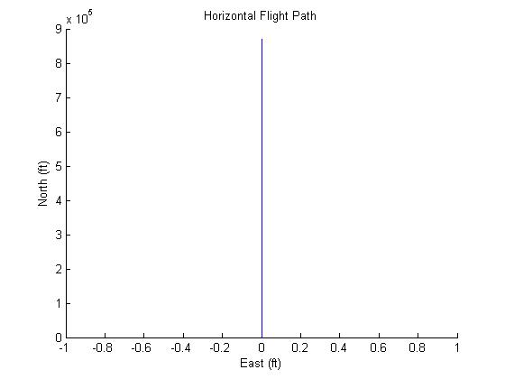

**Fig 1.3** – Plot showing the Horizontal Flight Path at the trim conditions

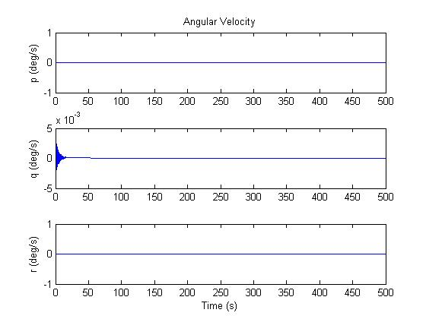

**Fig 1.4** – Plot showing the Angular Velocity component (*p*, *q*, *r*) response at the trim condition

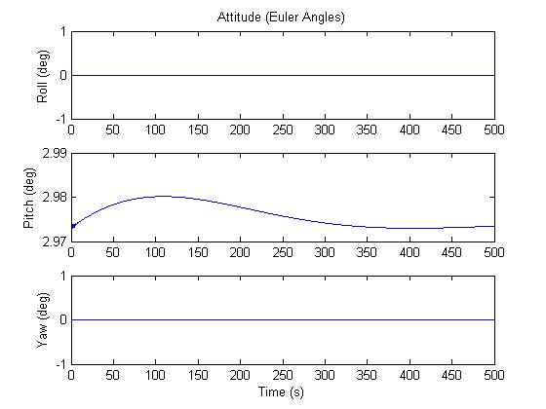

**Fig 1.5** – Plot showing the Attitude (Pitch, Roll and Yaw) response at the trim condition

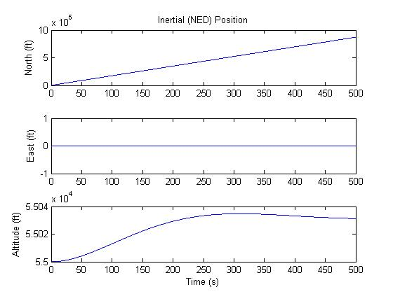

**Fig 1.6** – Plot showing the Inertial Position (North, East and Altitude) response at the trim condition

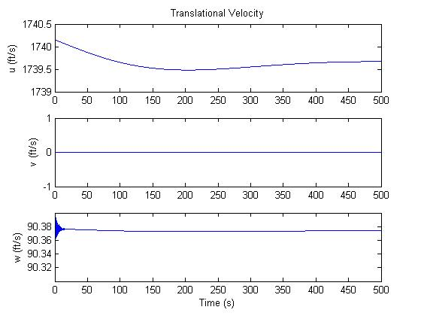

**Fig 1.7** – Plot showing the Translational Velocity (*u*, *v*, *w*) response at the trim condition

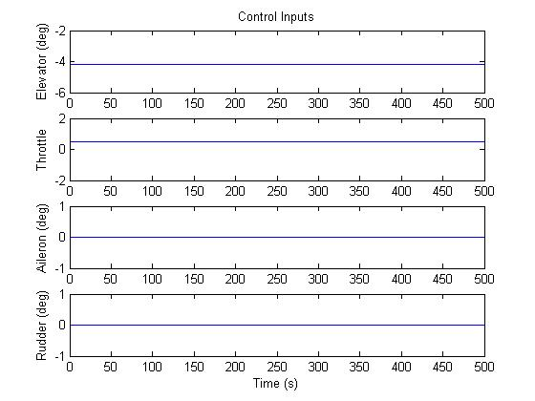

**Fig 1.8** – Plot showing the Control Input (Elevator, Throttle, Aileron, and Rudder) response at the trim condition

## 1.5 Open-Loop Control Input Simulation

Through the use of Matlab and Simulink, the aircraft was simulated through varying control input cases.

### Case 1 – Elevator Doublet

For Case 1, the elevator was modified and the following conditions were applied:

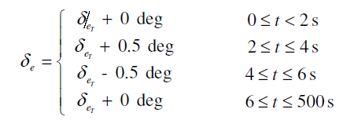

The following output plots were obtained from this simulation:

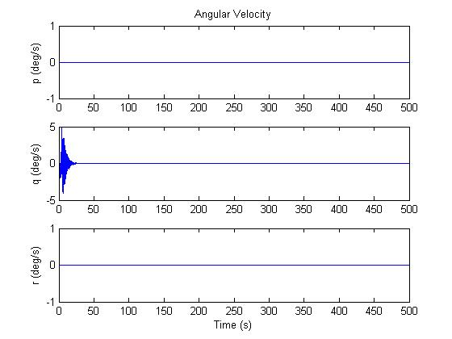

**Fig 1.9** – Plot showing the Angular Velocity component (*p*, *q*, *r*) response at the Case 1 condition

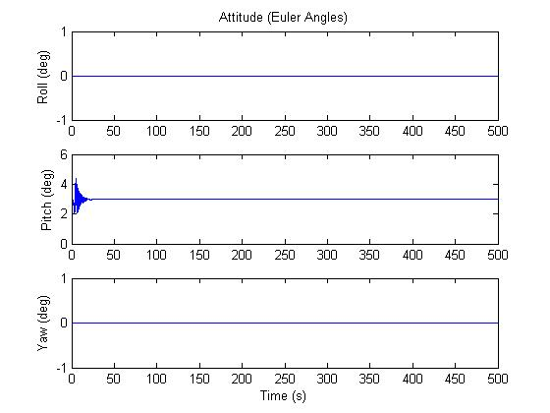

**Fig 1.10** – Plot showing the Attitude (Pitch, Roll and Yaw) response at the Case 1 condition

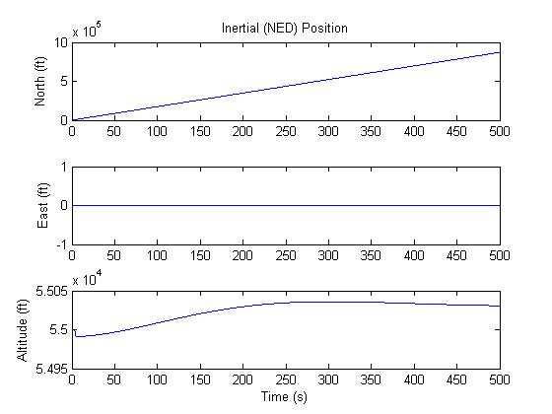

**Fig 1.11** – Plot showing the Inertial Position (North, East and Altitude) response at the Case 1 condition

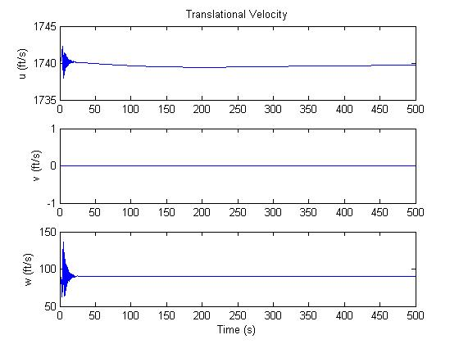

**Fig 1.12** – Plot showing the Translational Velocity (*u*, *v*, *w*) response at the Case 1 condition



**Fig 1.13** – Plot showing the Horizontal Flight Path at the Case 1 condition

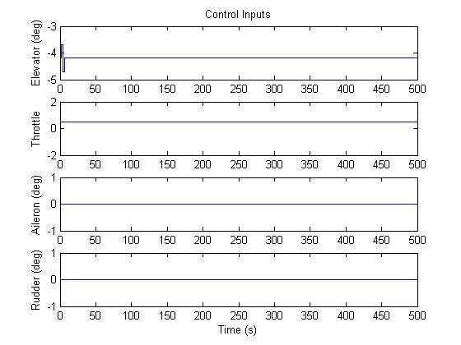

**Fig 1.14** – Plot showing the Control Input (Elevator, Throttle, Aileron, and Rudder) response at the Case 1 condition

### Case 2 – Aileron Doublet

For Case 1, the aileron was modified and the following conditions were applied:

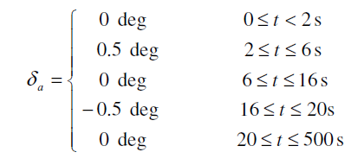

The following output plots were obtained from this simulation:

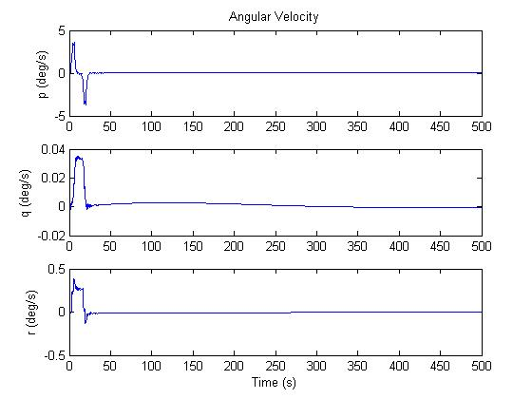

**Fig 1.15** – Plot showing the Angular Velocity component (*p*, *q*, *r*) response at the Case 2 condition

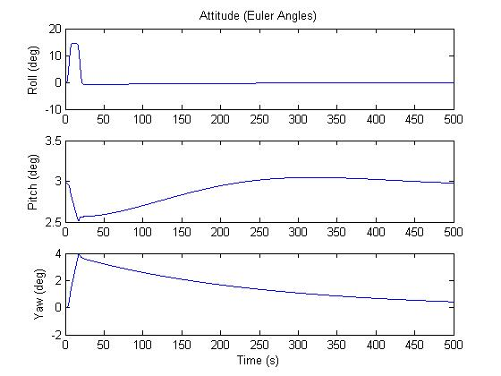

**Fig 1.16** – Plot showing the Attitude (Pitch, Roll and Yaw) response at the Case 2 condition

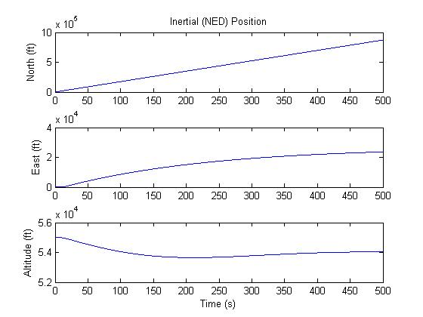

**Fig 1.17** – Plot showing the Inertial Position (North, East and Altitude) response at the Case 2 condition

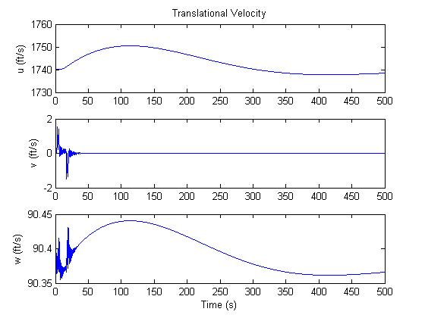

**Fig 1.18** – Plot showing the Translational Velocity (*u*, *v*, *w*) response at the Case 2 condition

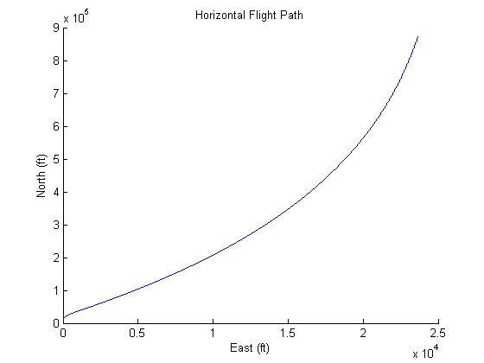

**Fig 1.19** – Plot showing the Horizontal Flight Path at the Case 2 condition

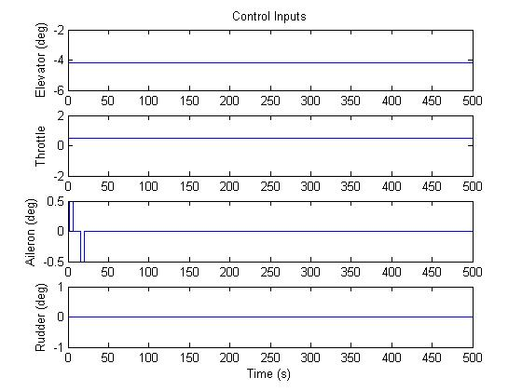

**Fig 1.20** – Plot showing the Control Input (Elevator, Throttle, Aileron, and Rudder) response at the Case 2 condition

### Case 3 – Rudder Doublet

For Case 1, the rudder was modified and the following conditions were applied:

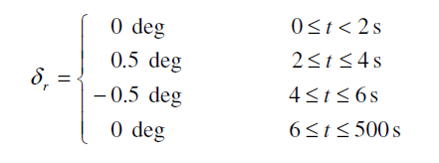

The following output plots were obtained from this simulation:

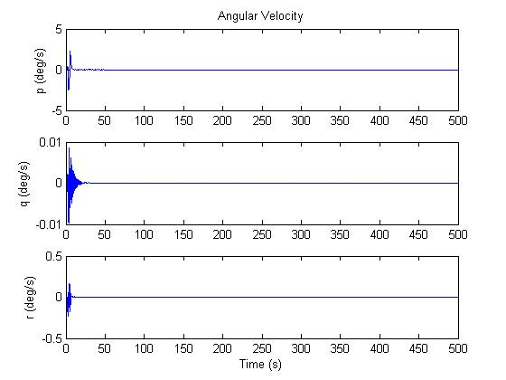

**Fig 1.21** – Plot showing the Angular Velocity component (*p*, *q*, *r*) response at the Case 3 condition

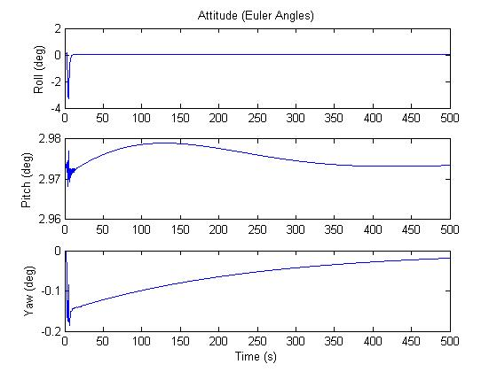

**Fig 1.22** – Plot showing the Attitude (Pitch, Roll and Yaw) response at the Case 3 condition

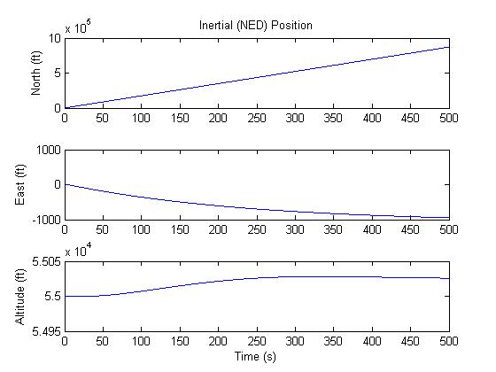

**Fig 1.23** – Plot showing the Inertial Position (North, East and Altitude) response at the Case 3 condition

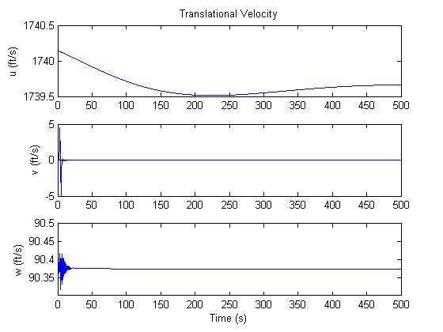

**Fig 1.24** – Plot showing the Translational Velocity (*u*, *v*, *w*) response at the Case 3 condition

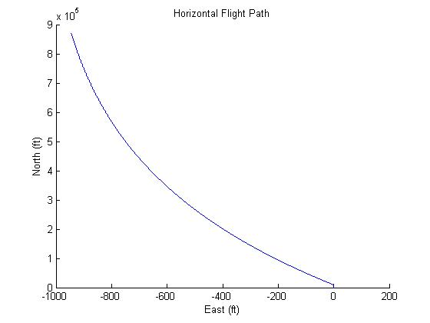

**Fig 1.25** – Plot showing the Horizontal Flight Path at the Case 3 condition

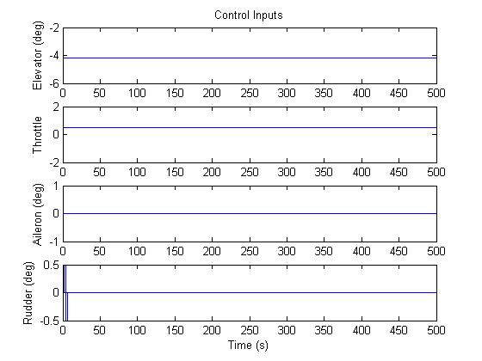

**Fig 1.26** – Plot showing the Control Input (Elevator, Throttle, Aileron, and Rudder) response at the Case 3 condition

## 1.6 Aircraft Stability Derivatives

The following tables, detail the longitudinal stability derivatives (Table 1-2) and lateral stability derivatives (Table 1-3) calculated through the use of Simulink and MATLAB for the F-104 Starfighter.

**Table 1-2:** Longitudinal stability derivatives of the F-104 Starfighter

|  |  |
| --- | --- |
| Property | Value |
|  | -0.0122 |
|  | -0.0086 |
|  | -0.0177 |
|  | -0.2013 |
|  | -0.0002186 |
|  | -0.8812 |
|  | -87.9087 |
|  | -0.00047336 |
|  | -0.0104 |
|  | -4.5075*10-5 |
|  | -0.1848 |
|  | -18.1609 |
|  | 0.0458 |
|  | 4.5668 |
|  | 1.1356*10-5 |
|  | 0 |
|  | 1742 |

**Table 1-3:** Lateral stability derivatives of the F-104 Starfighter

|  |  |
| --- | --- |
| Property | Value |
|  | -0.1010 |
|  | 14.6432 |
|  | -0.8874 |
|  | 0.5024 |
|  | 8.9447 |
|  | 4.0946 |
|  | -0.0182 |
|  | -0.0777 |
|  | -1.3528 |
|  | 0 |
|  | 0 |
|  | 0 |

## 1.7 Linear Longitudinal and Lateral Models

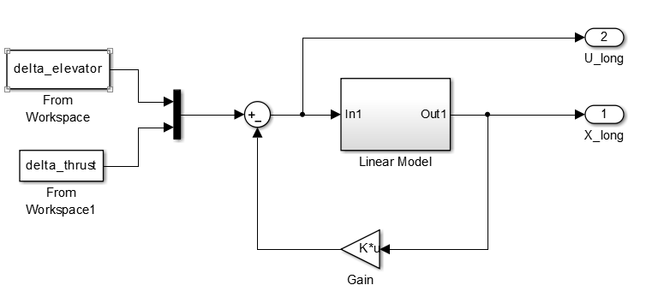

**Fig 1.27** – Longitudinal linearized model in Simulink

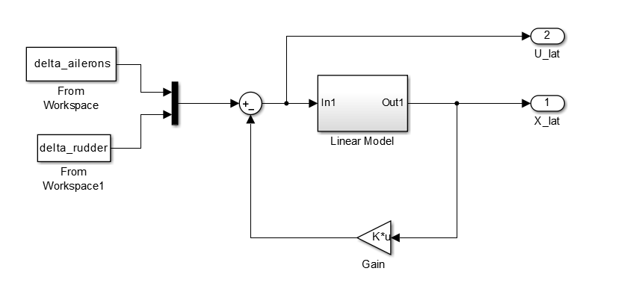

**Fig 1.28** – Lateral linearized model in Simulink

Figure 1.27 and Figure 1,28 shown above present the longitudinal and lateral Simulink models for the F-104 Starfighter. It should be noted that the models both contain feedback loops in order to linearize the model which contain both the A and B models. These calculations can only be performed when a trimmed model is used as per the process of the previous sections.

## 1.8 Open-Loop Eigenvalues

The Longitudinal Eigenvalues for the F-104 Starfighter are:

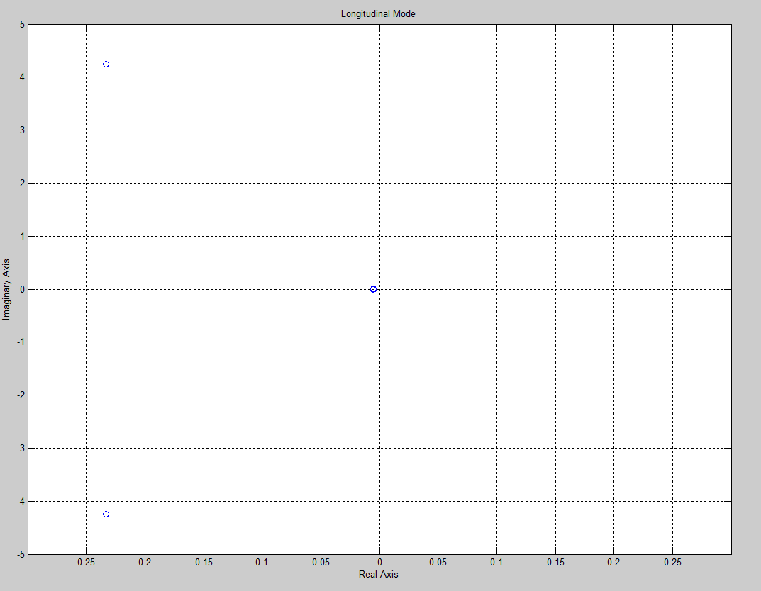

**Fig 1.29** – Plot of the longitudinal eigenvalues for the F-104 Starfighter

The Lateral Eigenvalues for the F-104 Starfighter are:

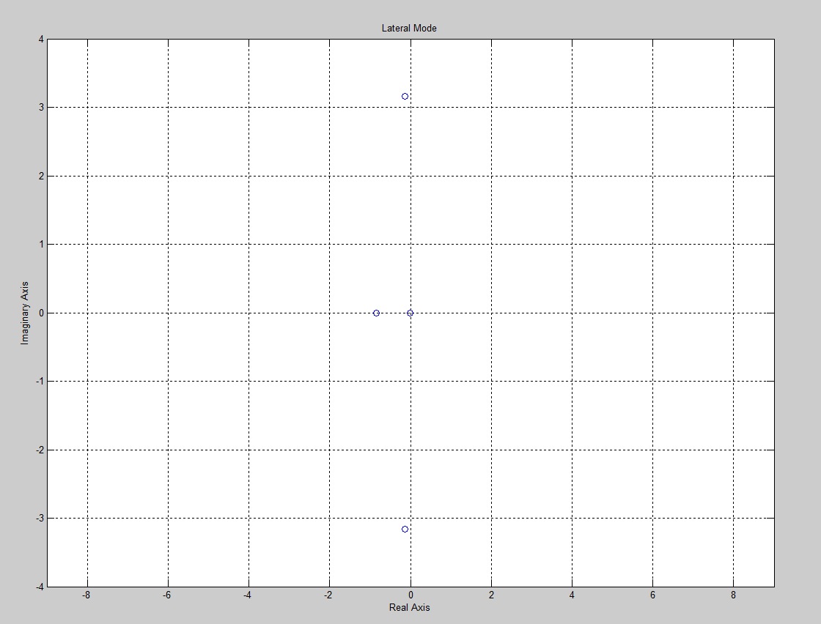

**Fig 1.30** – Plot of the lateral eigenvalues for the F-104 Starfighter

### Natural Frequency & Damping Ratio

**Longitudinal Mode**

The Natural Frequency () and Damping Ratio () were calculated for the Long Period mode through the use of MATLAB. The values are presented in Table 1-4 below.

**Table 1-4:** Natural frequency and damping ratio for long period mode

|  |  |
| --- | --- |
| Property | Value |
|  | 0.0121 rad/s |
|  | 0.4350 |
| Level | 1 |

The Natural Frequency () and Damping Ratio () were calculated for the Short Period mode through the use of MATLAB. The values are presented in Table 1-5 below.

**Table 1-5:** Natural frequency and damping ratio for short period mode

|  |  |
| --- | --- |
| Property | Value |
|  | 4.2562 rad/s |
|  | 0.0548 |
| Level | 1 |

**Lateral Mode**

The Natural Frequency () and Damping Ratio () were calculated for the Dutch Roll mode through the use of MATLAB. The values are presented in Table 1-6 below.

**Table 1-6:** Natural frequency and damping ratio for Dutch roll mode

|  |  |
| --- | --- |
| Property | Value |
|  | 3.1646 rad/s |
|  | 0.0412 |
| Level | 2 |

The Roll mode time constant was calculated through the use of MATLAB. It’s value and the associated eigenvalue is presented in Table 1-7 below.

**Table 1-7:** Time constant for Roll mode

|  |  |
| --- | --- |
| Property | Value |
|  | -0.0042 |
|  | 236.6555 |
| Level | 1 |

The Spiral mode time constant was calculated through the use of MATLAB. It’s time to double and the associated eigenvalue is presented in Table 1-8 below.

**Table 1-8:** Spiral mode time to double

|  |  |
| --- | --- |
| Property | Value |
|  | -0.8506 |
|  | 0.8147 sec |
| Level | 1 |

## 1.9 Linear Model Simulation

The simulation results of the linear model for the F-104 Starfighter is presented below in Figure 1.31 and Figure 1.32. The figures also show a comparison of the linear simulations results to results obtained using the nonlinear model using the same equivalent control inputs. This is done by superimposing the results of both models on top of each other.

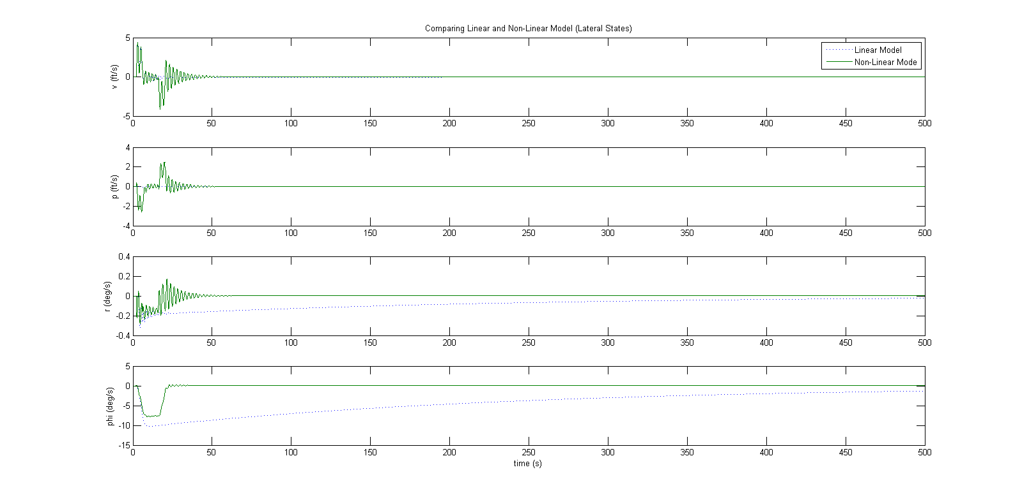

**Fig 1.31** – Plot showing linear and non-linear results for the longitudinal model, F-104 Starfighter

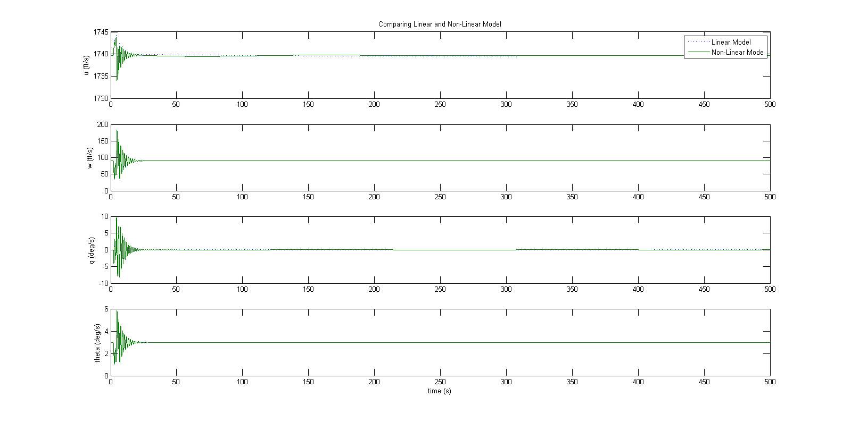

**Fig 1.32** – Plot showing linear and non-linear results for the later model, F-104 Starfighter

# 2. Stability Augmentation System

## 2.1 Open-Loop and Closed-Loop (SAS) Modes

In order to determine the following values, Level 1 flying quality requirements were taken into consideration.

### Phugoid Mode

From Deliverable #3, it was found the F-104 Starfighter’s Phugoid mode met Level 1 requirements and as a result, the Phugoid damping ratio was increased by 10% from the base value. This is shown in Table 2-1 below.

**Table 2-1:** Phugoid damping ratio values

|  |  |
| --- | --- |
| Property | Value |
| ζold | 0.4350 |
| ζnew | 0.4785 |

### Short Period Mode

From Deliverable #3, it was found the F-104 Starfighter’s Short Period mode met Level 1 requirements and as a result, the short period damping ratio was increased by 10% from the base value. This is shown in Table 2-2 below.

**Table 2-2:** Short Period damping ratio values

|  |  |
| --- | --- |
| Property | Value |
| ζold | 0.0548 |
| ζnew | 0.0602 |

### Roll Mode

From Deliverable #3, it was found the F-104 Starfighter’s Roll mode met Level 1 requirements and as a result, the magnitude of the roll mode eigenvalue ratio was not altered from the base value from the base value. This is shown in Table 2-3 below.

**Table 2-3:** Roll mode eigenvalue

|  |  |
| --- | --- |
| Property | Value |
| λroll | -0.0042 |

### Closed-Loop Spiral Mode

In order to determine the closed-loop spiral mode eigenvalue, it was necessary to ensure that the time-to-half was 10 seconds. As a result of meeting this requirement, the closed-loop spiral eigenvalue met Level 1 requirements. This is shown in Table 2-4 below.

**Table 2-4:** Closed-Loop spiral mode eigenvalue

|  |  |
| --- | --- |
| Property | Value |
| λspiral, old | -0.8506 |
| λspiral, new | -0.0693 |

### Dutch Roll Mode

In order to determine the Dutch roll damping ratio, the Level 1 requirements were taken into consideration. As a result of the Dutch roll damping ratio only meeting Level 2 and not meeting Level 1 requirements, it was necessary to increase it so that it does. This is shown in Table 2-5 below.

**Table 2-5:** Dutch roll mode damping ratio

|  |  |
| --- | --- |
| Property | Value |
| ζold | 0.0412 |
| ζnew | 0.1733 |

Table 2-6 below shows the open-loop (i.e. stability without augmentation) and closed-loop (i.e. with stability augmentation) modes for the Starfighter.

**Table 2-6:** Comparison of Open-Loop and Closed-Loop mode values

|  |  |  |
| --- | --- | --- |
| Mode | Open Loop λ | Closed Loop λ |
| Phugoid | -0.0053 + 0.0109i | -0.0058 + 0.0106i |
| Short Period | -0.2330 + 4.2498i | -0.2563 + 4.2484i |
| Roll | -0.0042 | -0.0042 |
| Closed-loop Spiral | -0.8506 | -0.8506 |
| Dutch Roll | -0.1303 + 3.1619i | -0.1503 + 0.8539i |

## 2.2 Lateral and Longitudinal Stability Augmentation Systems

### Bass-Gura Numerical Method

In order to calculate the gain matrices required for the Starfighter’s lateral and longitudinal stability augmentation systems. It should be noted that for the longitudinal stability augmentation, only the elevator was used and the throttle was ignored. The gain matrices for the longitudinal and lateral stability augmentation are presented below. Also,

## 2.3 Simulation Results with Disturbances

The derived stability augmentation control laws were implemented on the linear longitudinal and lateral models. To do this, the lateral and longitudinal Simulink models were modified to include the state feedback (stability augmentation). The following simulations were performed in response to different initial conditions. It should be noted that these conditions represent disturbances from equilibrium.

### Longitudinal

The initial conditions were set to the following values and the simulation was run:



The following output plots were obtained from the simulation showing the comparison of the open-loop and closed-loop results.

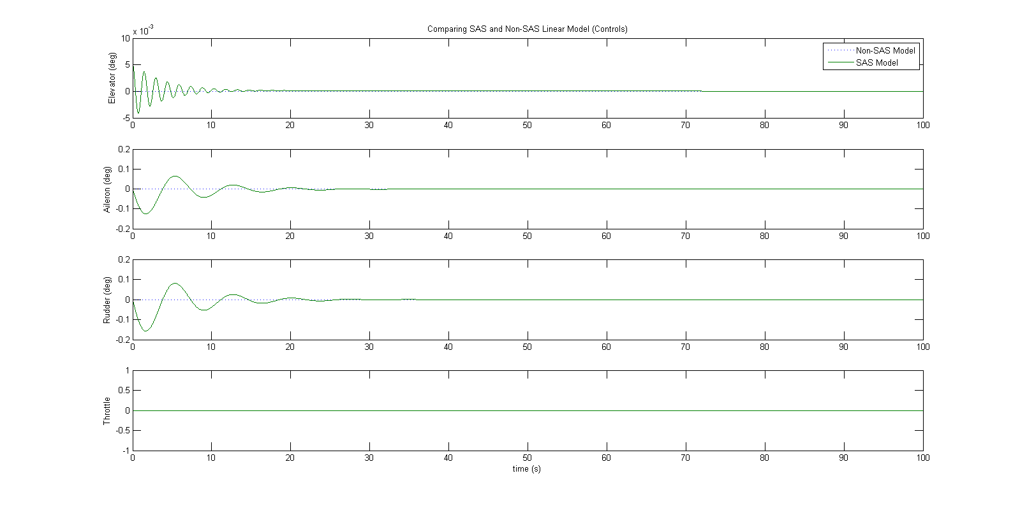

**Fig 2.1** – Plot of longitudinal control inputs

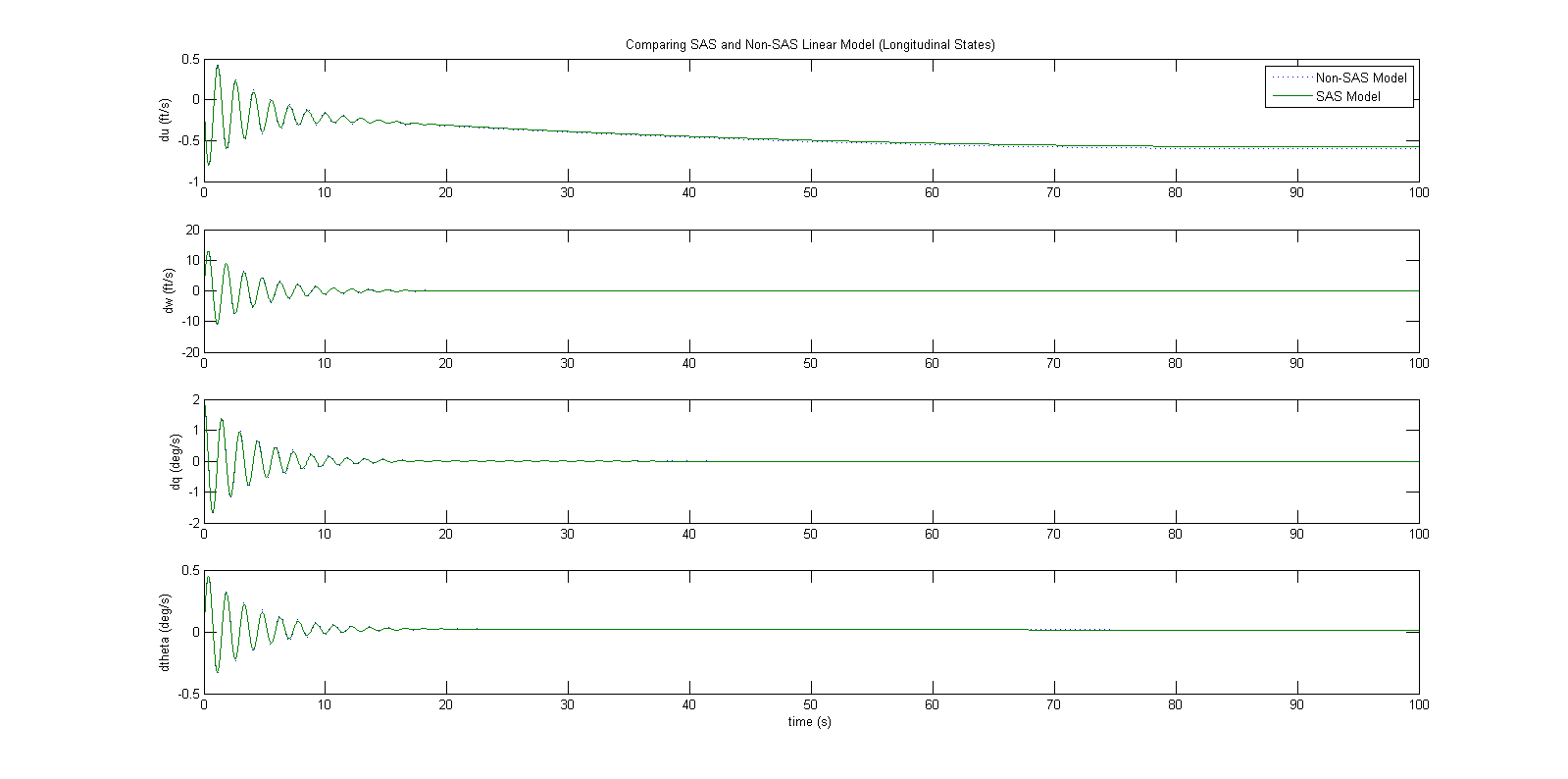

**Fig 2.2** – Plot of longitudinal variables

### Lateral

The initial conditions were set to the following values and the simulation was run:



The following output plots were obtained from the simulation showing the comparison of the open-loop and closed-loop results.



**Fig 2.3** – Plot of lateral control inputs

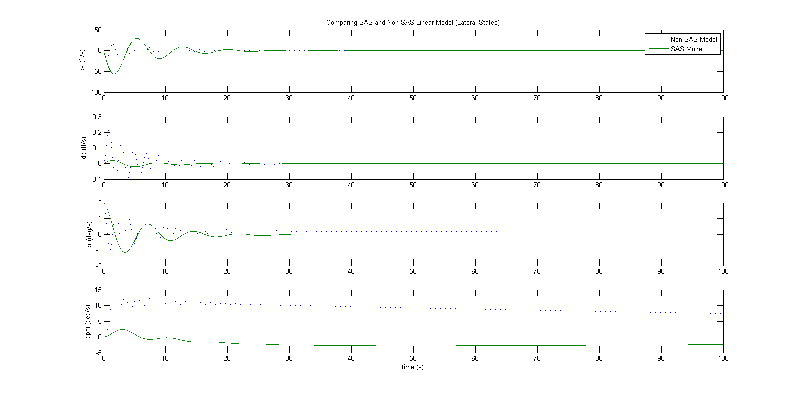

**Fig 2.4** – Plot of lateral variables

## 2.4 Simulation Results (SAS Implementation)

The lateral and longitudinal stability augmentations systems were implemented into the model for the Starfighter. In order to achieve this, it was necessary to modify the nonlinear simulation Simulink Model to incorporate the state feedback control. The following simulations were performed in response to differing initial conditions as detailed below. The plots also show a comparison of the system with and without the stability augmentation implemented.

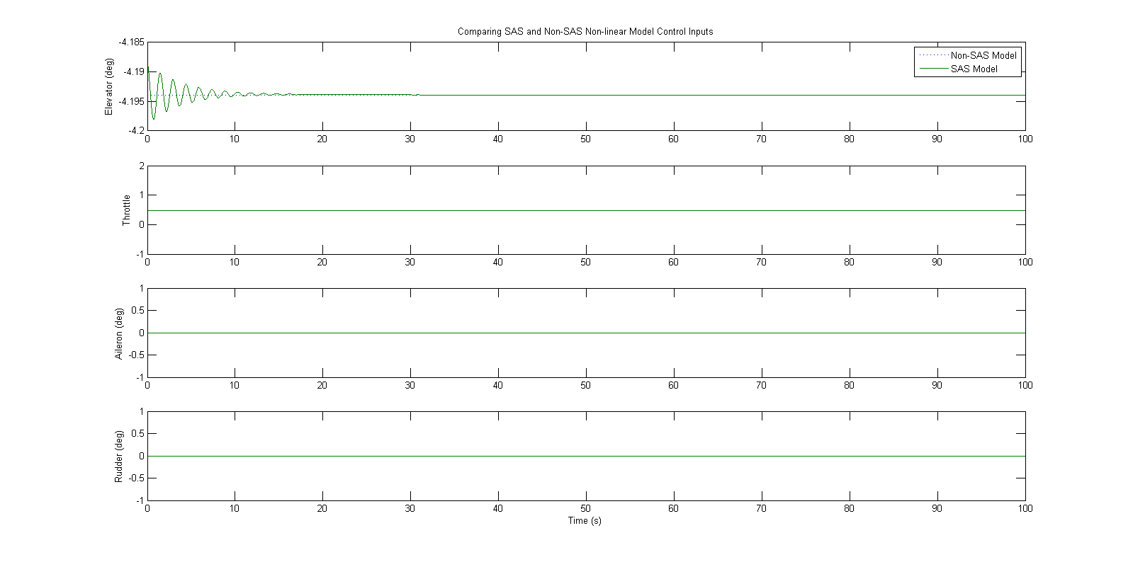

**Fig 2.5** – Plot of non-linear control inputs

### Lateral

From Figure 2.6 below, we can see that the overall effect of implementing the SAS into the lateral model state is stabilizing. This is shown by the evening out of even the smallest disturbances in the model.

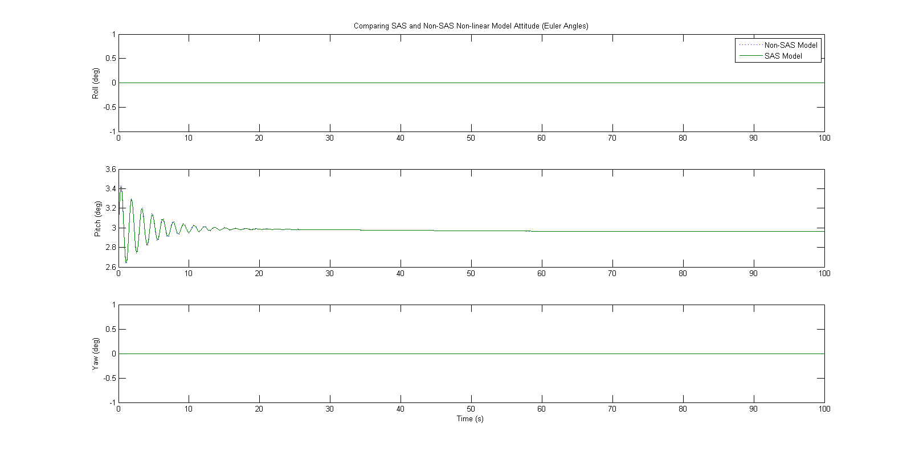

**Fig 2.6** – Plot of non-linear lateral model outputs

### Longitudinal

From Figure 2.7 below, we can see that the overall effect of implementing the SAS into the lateral model state is stabilizing. This is shown by the evening out of even the smallest disturbances in the model. It is clearly visible that the closed loop system dissipates disturbances far better that open-loop system from the results below.

**Fig 2.7** – Plot of non-linear longitudinal model outputs

# 3. Autopilot Control Design

## 3.1 Controller Design Process

It was desired that four (4) autopilot systems were to be designed. These systems are roll control, heading hold, velocity hold and altitude hold. It was determined that the best controller to fulfill the mission requirements was a PID controller. PID was chosen because it provides the best steady state error response combined with minimization of the overshoot of the controller.

A PI controller was not chosen due to the fact that it does not respond well to steady state error. A PD controller was also not chosen due to the fact that it does not deal well when dealing with excessive overshoot beyond what is desired.

In order to design the autopilot system, the value for was chosen to be 1 and to be 1 second. From these choices, the following actuator transfer function was yielded:

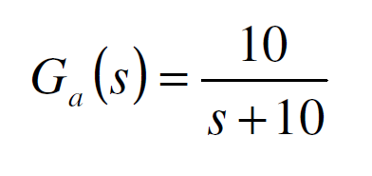

It was also desired that an additional lag transfer function be implemented to take into account the lag associated with the response of the engine thrust when an action is commanded. Due to the fact that the F-104 Starfighter has jet engines the following transfer function was used:

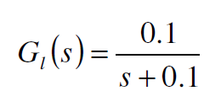

Through the use of the Ziegler-Nichol method, a locus plot was created in MATLAB. Once properly created, the critical gain, was determined along with the gain values of KP, KI and KD for the 4 autopilot systems. The outputted values are shown in Table 3-1 below.

**Table 3-1:** Gain Values used for the 4 autopilot systems

|  |  |  |  |
| --- | --- | --- | --- |
| Property | KP | KI | KD |
| Roll Control | 0.0238 | 0.0004534 | 1.1412 |
| Heading Hold | 0 | 0.1304 | 0 |
| Velocity Hold | 1.1153 | 5.803 | 0.04762 |
| Altitude Hold | 2.0514*10-6 | 1.569 | 0  0003412 |

## 3.2 Simulation Results

This section details the simulations results using each individual controller on the full linear longitudinal model in response to a commanded step input. The results are detailed in the figures presented below.

### Roll Control

For the roll control, a step input for a roll of 10 degrees was commanded using the aileron. The response is shown below.

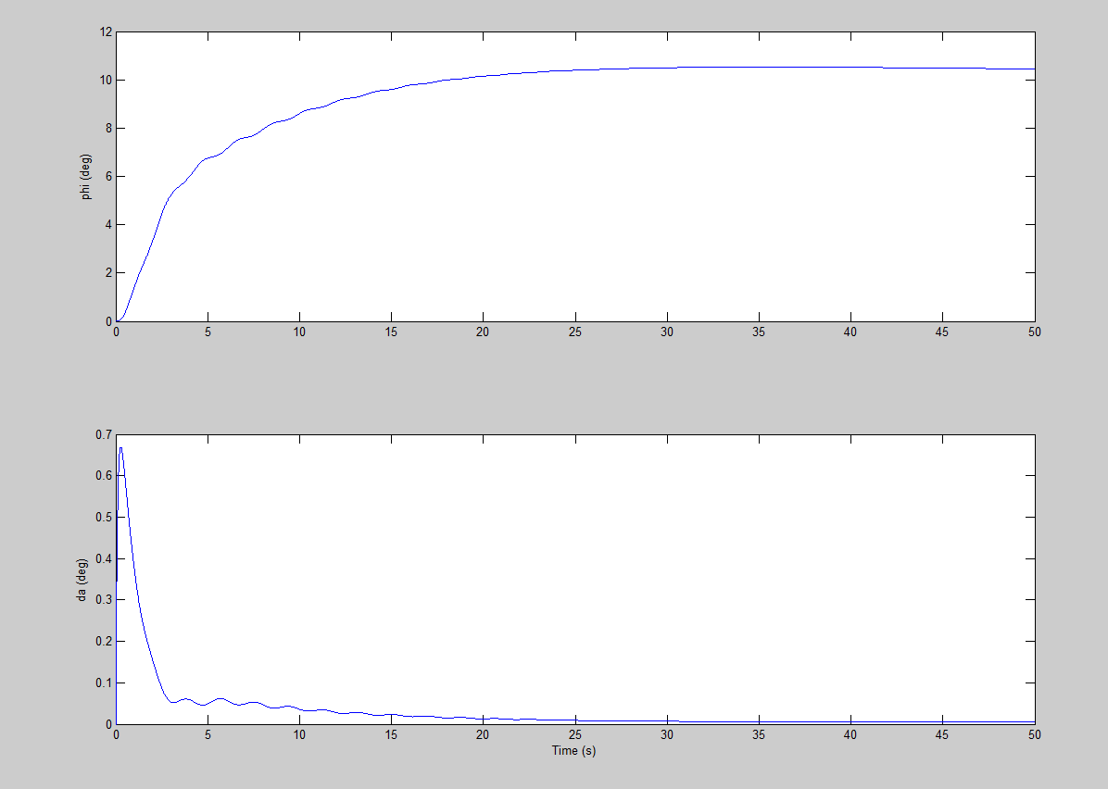

**Fig 3.1** – Plot of aileron command with roll hold

From figure 3.1 we can see that the aileron responded quickly to the inputted command and held the desired deflection of 10 degrees over the time period.

### Heading Hold

For the heading hold, a step input for a sideslip of 10 degrees was commanded using the rudder. The response is shown below.

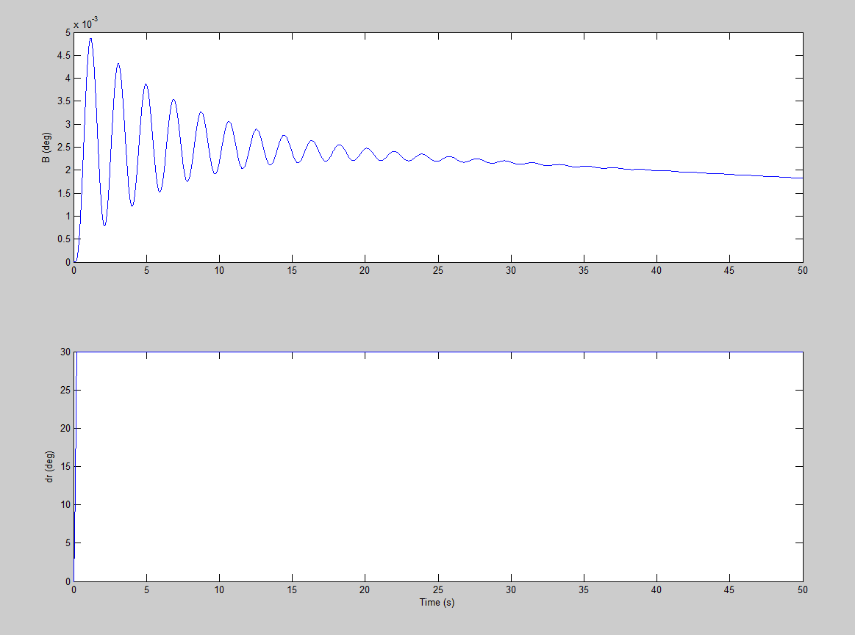

**Fig 3.2** – Plot of rudder command with heading hold

From Figure 3.2 we can see that although there was overshoot, the rudder eventually settled to the desired deflection after a reasonable amount of time as commanded..

### Altitude Hold

For the altitude hold, a step input for an altitude of 10 feet was commanded using the elevator. The response is shown below.

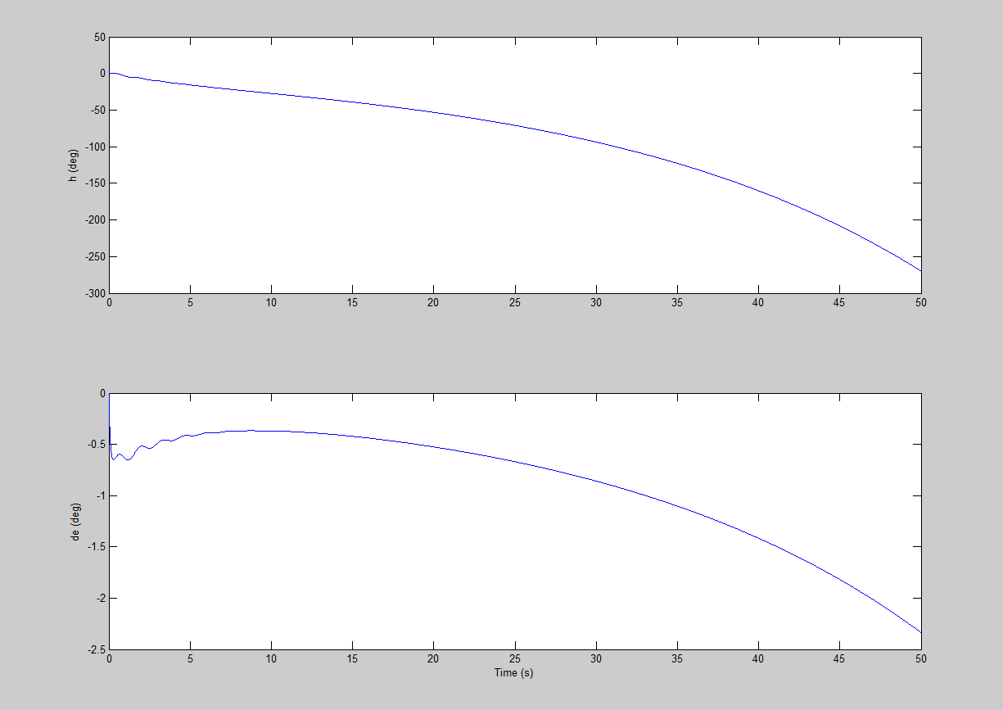

**Fig 3.3** – Plot of elevator command with altitude hold

Figure 3.3 shows that with the commanded elevator deflection, we can see that the expected response with respect to altitude occurs. The aircraft decreases in altitude at a uniform rate.

### Velocity Hold

For the velocity, a step input for a roll of 10 feet per second was commanded using the rudder for sideslip at a velocity of 350 ft/s using the thrust control. The response is shown below.

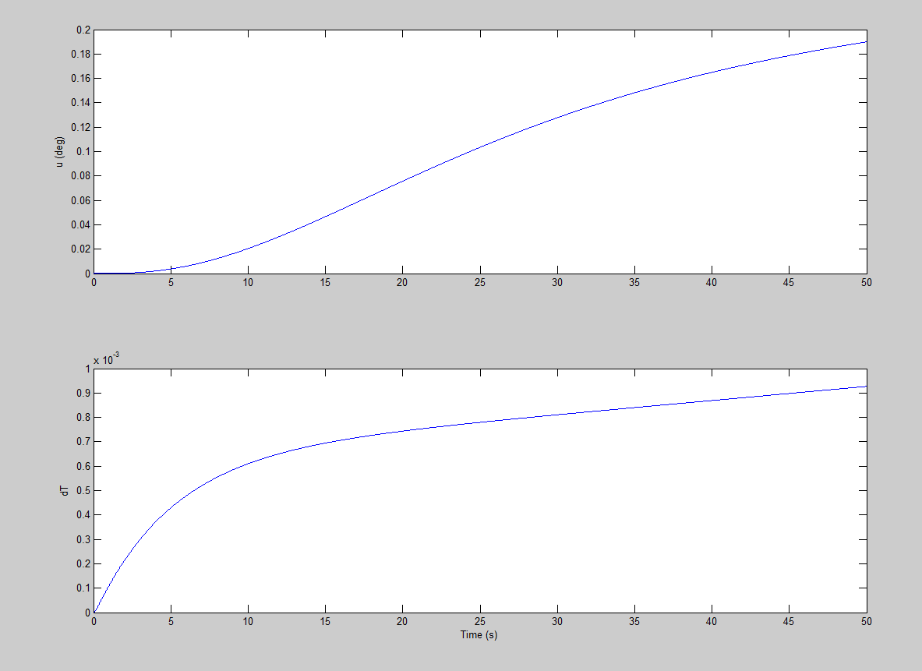

**Fig 3.4** – Plot of thrust command with velocity hold

From Figure 3.4, we can see that although the thrust response is relatively slow when compared to that of an actuator, the autopilot system still manages to control the F-104 Starfighter’s velocity as desired.

# 4. Waypoint Navigation

## 4.1 Waypoint Navigation Simulation

Through the use of the autopilots systems detailed in Section 3 of this report, the aircraft was commanded to fly through a series of waypoints which resembled a “Figure 8” pattern. This was done through the integration of the autopilot systems, using linear models, into the full 6-DOF nonlinear aircraft simulation for the F-104 Starfighter. The nonlinear simulation includes actuator models and saturation limits which represent the upper and lower limits on each commanded control input for the simulation. Also, the thrust control limits on the engines of the F-104 Starfighter were limited from 0 (engine off, zero thrust) to 1 (maximum thrust or power).

It should also be noted that the control surface inputs were limited to a default of 30 degrees for the rudder, aileron and elevator of the F-104 Starfighter for this waypoint navigation simulation.

## 4.2 Simulation Results

The results of the waypoint navigation simulation are shown in the figures below.

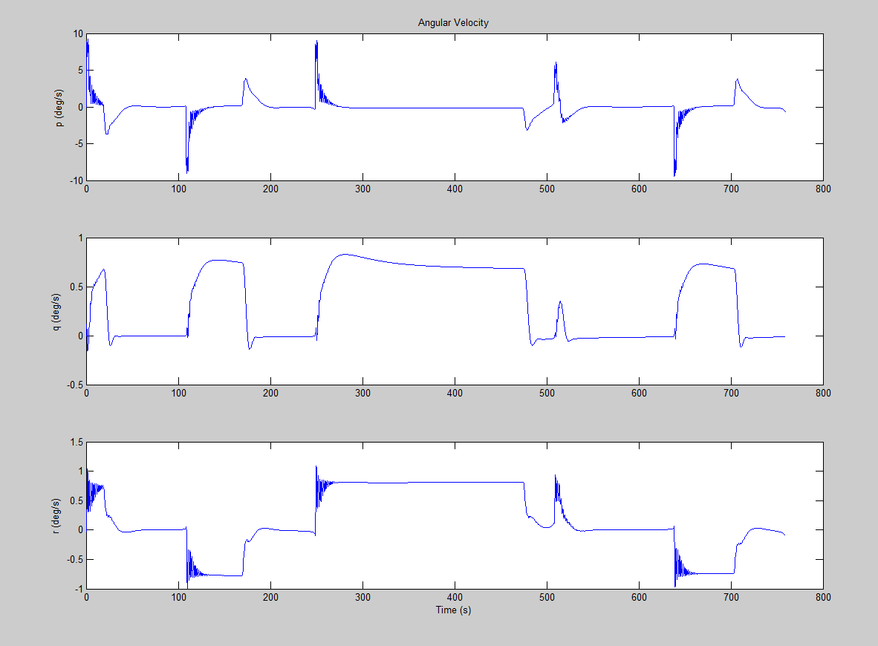

**Fig 4.1** – Angular velocity components during mission simulation

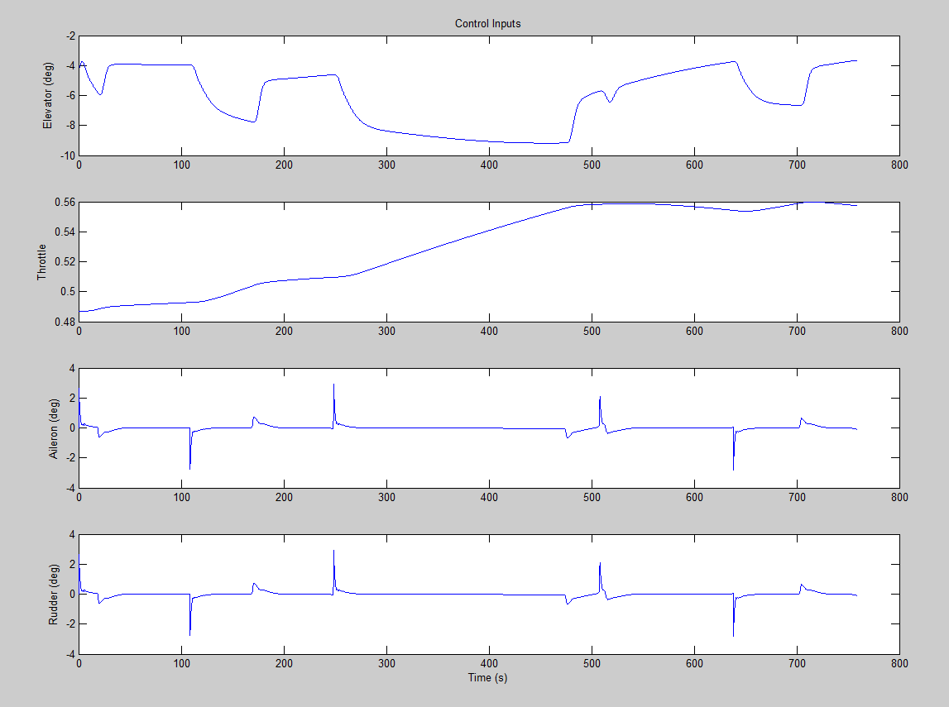

**Fig 4.2** – Control inputs during mission simulation

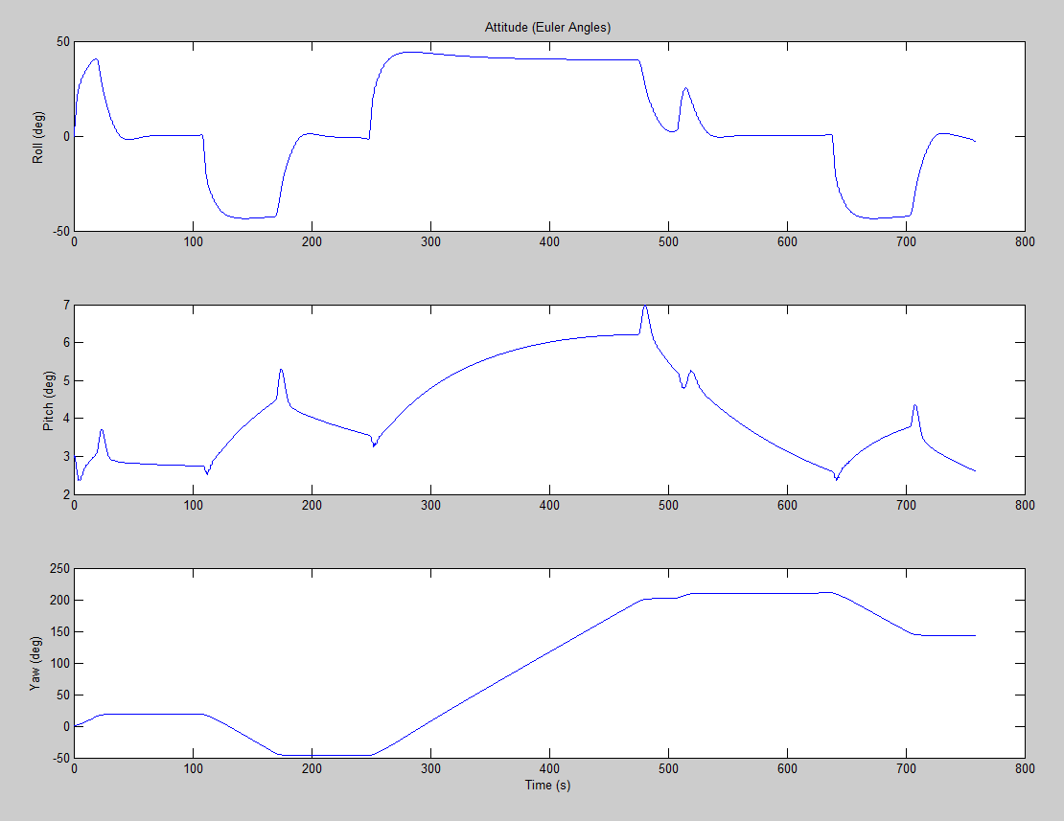

**Fig 4.3** –Altitude (Euler angles) during mission simulation

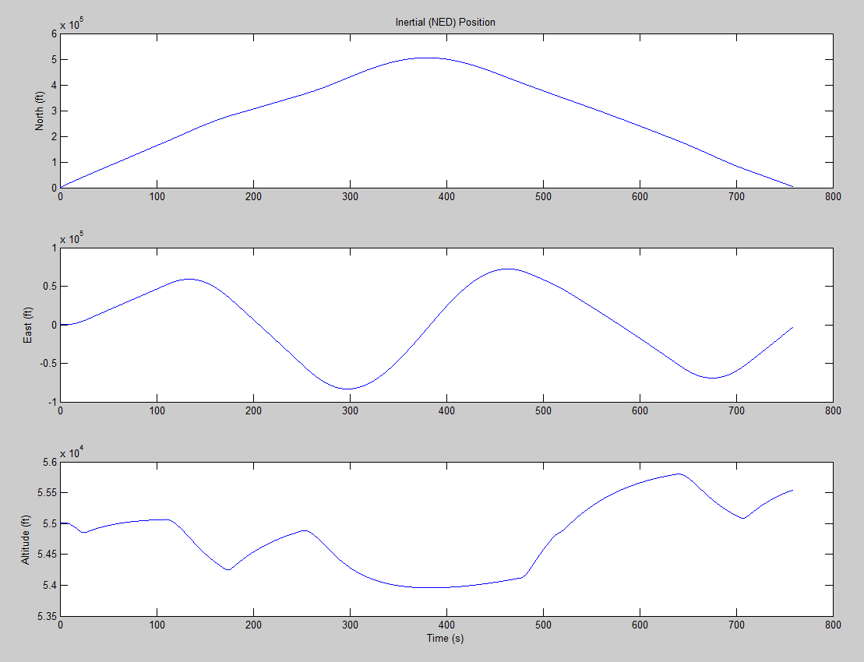

**Fig 4.4** –Inertial (NED) positons during mission simulation

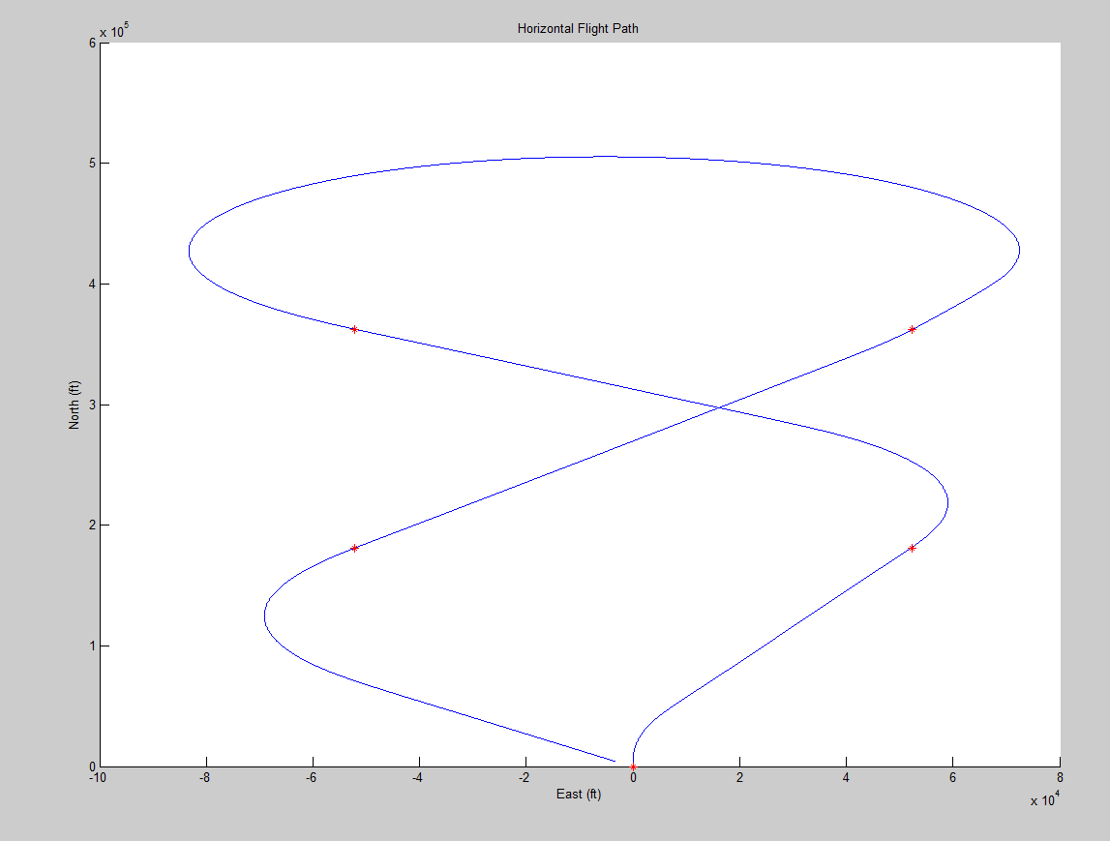

**Fig 4.5** – Navigation path during mission simulation

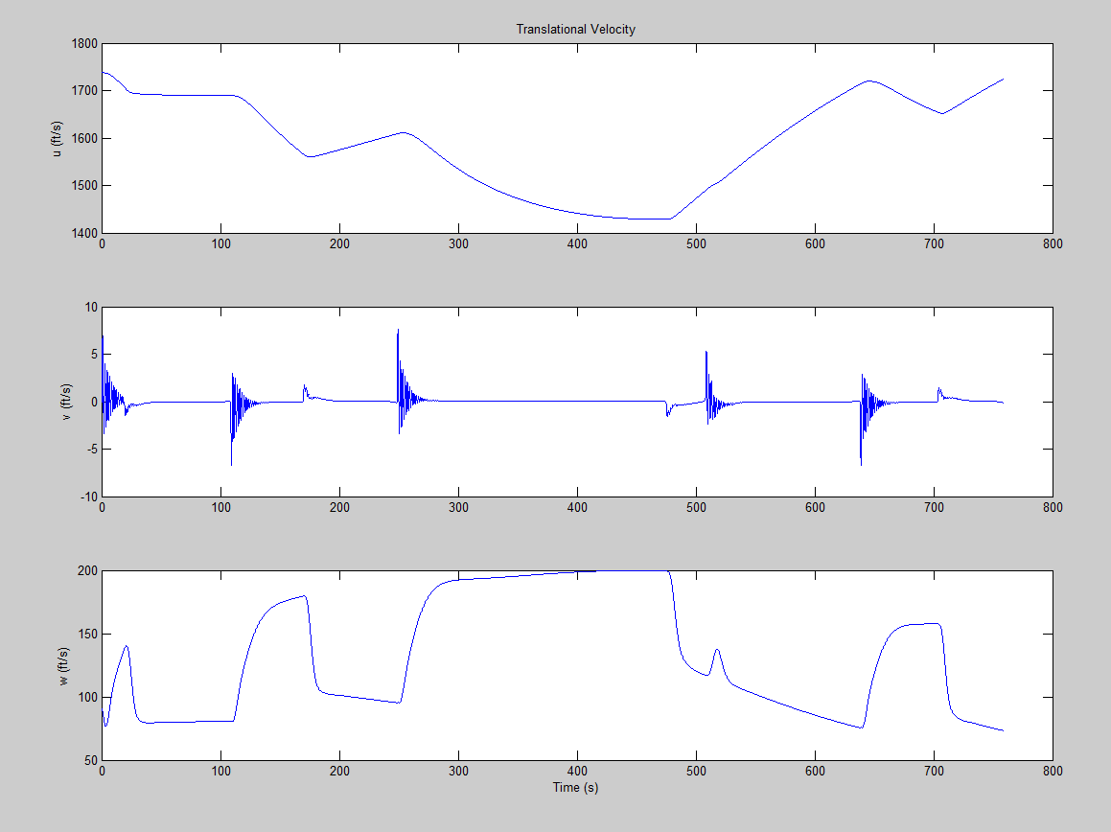

**Fig 4.6** – Translational velocity components during mission simulation

Overall the simulation completed its job. All check points were achieved and passed by them almost directly. This happens because the buffer zones were not implemented due to time. Some of the controls were maxed out because the limits needed to be increased for the simulation to work properly. This could have been avoided if we were able to implement these buffer zones. The aircraft did lose significant speed due to its high cruise speed and the radius of the turns that were made. This also cause the plane to bank enough to lose altitude in every turn but recovered it

# 5. Conclusion

The preceding report outlines the response of the Lockheed F-104 Starfighter to the requested conditions. It also shows it’s performance when a series of autopilot systems are implemented and aircraft is asked to navigate a series of waypoints.

Through the use of Simulink and MATLAB a simulations model was developed and analyzed in the open loop configuration. Once the aircraft was verified to be stable, a stability augmentation system was developed and implemented. An autopilot system was then developed for roll control, heading hold, velocity hold and altitude hold and once verified working, the aircraft was flown through a set of predetermined waypoints.

The simulation concurred with the historical and theoretical observations quantitatively and qualitatively, implying that the simulation successfully completed each of its objectives. From the performance of the aircraft through the simulation carried out in this project, it can be said that the F-104 Starfighter is stable at the given conditions.